**Sentiment Analysis Of Customer Feedback Restaurants Using IBM Cloud**

An Internship Project Report

Submitted By

(BATCH NO: CSE_AIML_D12)

T.BHAVANI (18481A05K6)

                              Y.RISHITHA (18481A05N5)

T.GREESHMA (18481A05L3)

  Y.SAMARASIMHAREDDY (18481A05N7)

**INDEX**

**TITLE PAGE NO**

**CHAPTER 1: INTRODUCTION 3**

* 1. OVERVIEW 3
  2. PURPOSE 3

**CHAPTER 2: LITERATURE SURVEY 4**

* 1. EXISTING PROBLEM 4
  2. PROPOSED SOLUTION 4

**CHAPTER 3: THEORTICAL ANALYSIS 5-7**

3.1 BLOCK DIAGRAM 5

3.2 HARDWARE/SOFTWARE DESIGNING 6-7

**CHAPTER 4: EXPERIMENTAL INVESTIGATIONS 7**

**CHAPTER 5: FLOW CHART 8**

**CHAPTER 6: RESULTS 9**

**CHAPTER 7: ADVANTAGES AND DISADVANTAGES 9-10**

**CHAPTER 8: APLLICATIONS 10**

**CHAPTER 9: CONCLUSION 10**

**CHAPTER 10: FUTURE SCOPE 11**

**CHAPTER 11: BIBILOGRAPHY 11**

**CHAPTER12: APPENDIX 12-15**

**CHAPTER 1**

**INTRODUCTION**

* 1. **Overview:**

Most of the customers will follow and choose the best restaurants on the basis of reviews and ratings. So reviews Play a Crucial Role in any model or system. The approach to this problem is based on review text content analysis and uses the principles of natural language process (the NLP method) and Machine learning. After applying the above method we can classify whether it is a positive review or negative review and can also visualize the total no of positive reviews and negative reviews. We are working on developing an algorithm that can help in classifying the reviews on the basis of positive and negative reviews with the help of a predefined dictionary of words.

A web Application is created where user can enter their feedback, the entered text is analyzed by the model built and prediction is showcased on UI

* 1. **Purpose:**

Sentiment analysis is called as finding the opinion from a large data which helps to analyze which restaurant is the best for customer who directly accesses the good reviews for restaurant.

**CHAPTER 2**

**LITERATURE SURVEY**

* 1. **Existing Problem:**

Many of the restautrants had the problem whether the customer had satisfied by our services or not. They cannot say the wheather the food is good or bad.So,many of the restaurants cannot develop their services based on the customer requirements . It is the main problem for the restaurants for their services.The customer feedback plays curcial role in restautrants to provide the good services. Since many years, service quality and customer satisfaction have become a major area of attention to researchers because it was found that both have impact on organization performance and customer behavior.

* 1. **Proposed Solution:**

We proposed a solution to develop the customer services online feedback.we

predict the customer is satisfied our services based on three types positive,negative and neutral.These three a catagorized analysis the customer textual data based on dataset provide and train the model. A satisfaction based on outcome or process is also termed as customers’ satisfaction. Customer satisfaction can simply be defined as judgment of a post consumption of a particular product or service

**CHAPTER 3**

**THEORTICAL ANALYSIS**

**3.1 Block Diagram:**

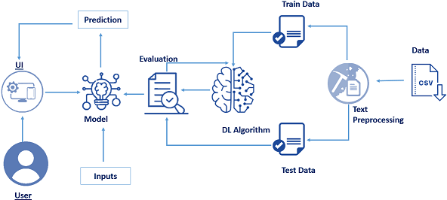

**3.2 Hardware/software designing:**

**Software specifications:**

|  |  |
| --- | --- |
| **REQUIREMENT** | **SPECIFICATIONS** |
| Anaconda Navigator | Anaconda Navigator is a free and open-source distribution of the Python and R programming languages for data science and machine learning related applications. It can be installed on Windows, Linux, and macOS. |
| Python | The version required to run this project is 3.7 0r 3.8 to install libraries. |
| numpy | The version required is 1.19.5 |
| pandas | pandas is a software library written for the Python programming language for data manipulation and analysis.The version required is 1.3.0. |
| tensorflow | TensorFlow provides a collection of workflows to develop and train models using Python.The version required is 2.5.0. |
| flask | The version is required is 2.0.1 |
| keras | The version is required is 2.5.0 |

**Hardware Specifications:**

|  |  |
| --- | --- |
| **REQUIREMENT** | **SPECIFICATIONS** |
| Operating system | Microsoft Windows  UNIX  Linux® |
| Processor | I3 or above |
| RAM | Minimum 4GB. |

**CHAPTER 4**

**EXPERIMENTAL INVESTIGATIONS**

In the contemporary world,people share their thoughts rapidly in social media.

Nowadays a large number of reviews posted by the viewers on the Web provide valuable information to other people.Such information is highly essential for decision making and hence popular among the internet users.This information is very valuable not only for the restaurants owners but also to customers in predicting the restaurant of the food. The aim of our project is to identify the underlying sentiment of customer feedback on restaurants on the basis of its textual information.

**CHAPTER 5**

**FLOW CHART**

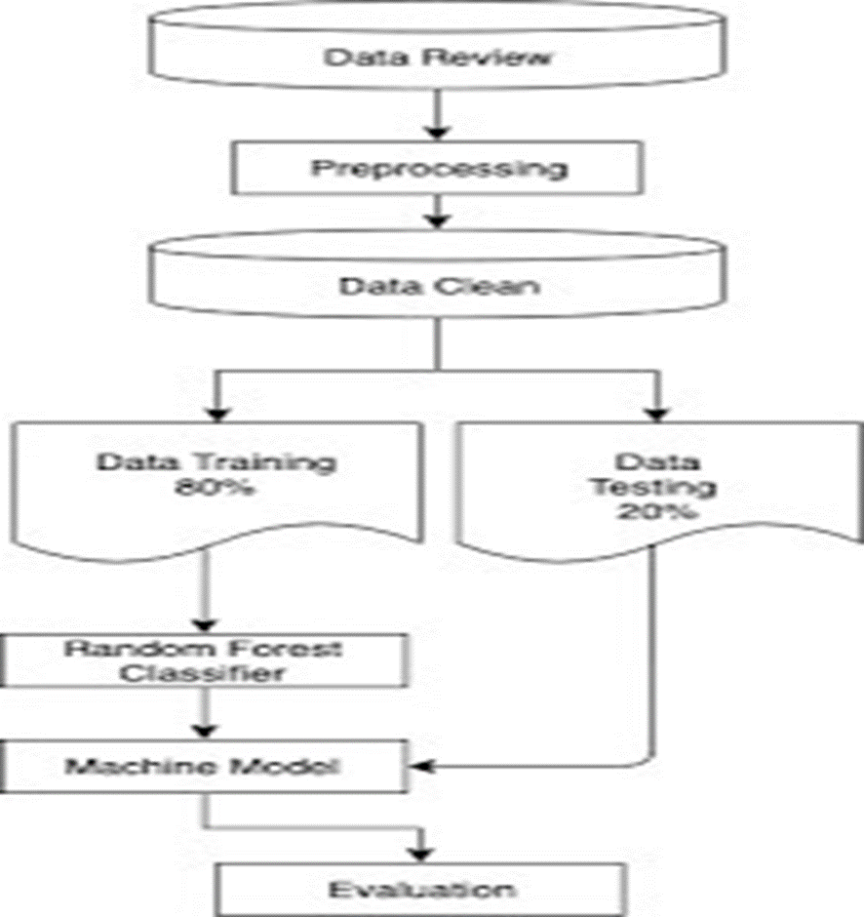

**CHAPTER 6**

**RESULTS**

* The user gives the input values from the UI interface which is created by using Flask Application.
* The user inputs are given to the AI which consists of the machine learning model.
* The model performs the data pre-processing and sentiment analysis using text-processing on the given input values and predicts the

**CHAPTER 7**

**ADVANTAGES AND DISADVANTAGES**

**Advantages**

* **Inexpensive Way to  Improve Your Products and Service.**
* Measure Customer Satisfaction
* **Create Best Customer Experience**
* **Improve Customer Retention and Loyalty Rates**
* **Reliable Source of Information About Other Competitors**

### Reduce Cost and Time Constraints

### **Easy to Track Changes Over a Period of Time**

**Disadvantages:**

### **Chances of Customer Dissatisfaction**

### **Concerns About Privacy**

### **Probability of Survey Fatigue**

### **Presence of Survey Biases**

Lower c Lower costs—red

**CHAPTER 8**

**APLLICATIONS**

Applications of sentiment analysis:

1. Social media monitoring.
2. Customer feedback
3. Service analysis.
4. Voice of customer.
5. Voice of employee.

**CHAPTER 9**

**CONCLUSION**

This process of text processing ,sentiment analysis is not only used for customer feedback but for other purposes likes movie reviews,online shopping etc .. Now a days this process is entering our daily lives in every aspect.

**CHAPTER 10**

**FUTURE SCOPE**

The future of sentiment analysis is going to continue to dig deeper ,far past the surface of the numbers of likes ,comments and shares ,and aim to reach ,and truly understand , the significance of social media interactions and what they tell us about the restaurants services to the customer . This forecast also predict broader applications for the sentiment analysis-brands will continue to leverage this tool,but so will individuals in the public eye, governments ,nonprofits,education center and many other organizations.

**CHAPTER 11**

**BIBILOGRAPHY**

References of previous works or websites visited/books referred for analysis about the project, previous solution findings etc.

<https://www.ijert.org/research/sentiment-analysis-of-customer-feedback-on-restaurants>.

<https://arxiv.org/ftp/arxiv/papers/1901/1901.01642>

<https://towardsdatascience.com/machine-learning-as-a-service-487e930265b2>

<https://www.acadpubl.eu/hub/2018-119-15/2/373>

.

**CHAPTER12**

**APPENDIX**

**Supervised and unsupervised learning:**

**Regression Classification and Clustering**

**Artificial Neural Networks**

**Natural Language Processing**

**Flask app**

**12.1**

* Data Collection
* Text Pre-processing
  + Import the Libraries.
  + importing the dataset
  + Remove Punctuations
  + Convert each word into a lower case.
  + Stemming.
  + Splitting Data into Train and Test.
* Model Building
  + import the model building Libraries
  + Initializing the model
  + Adding Input Layer
  + Adding Hidden Layer
  + Adding Output Layer
  + Configure the Learning Process
  + Training and testing the model
  + Optimize the Model
  + Save the Model
* Application Building
  + Build HTML Page
  + Build python Code

**12.2 Output Screeshots**

